* Do login by your MIS User name and Password

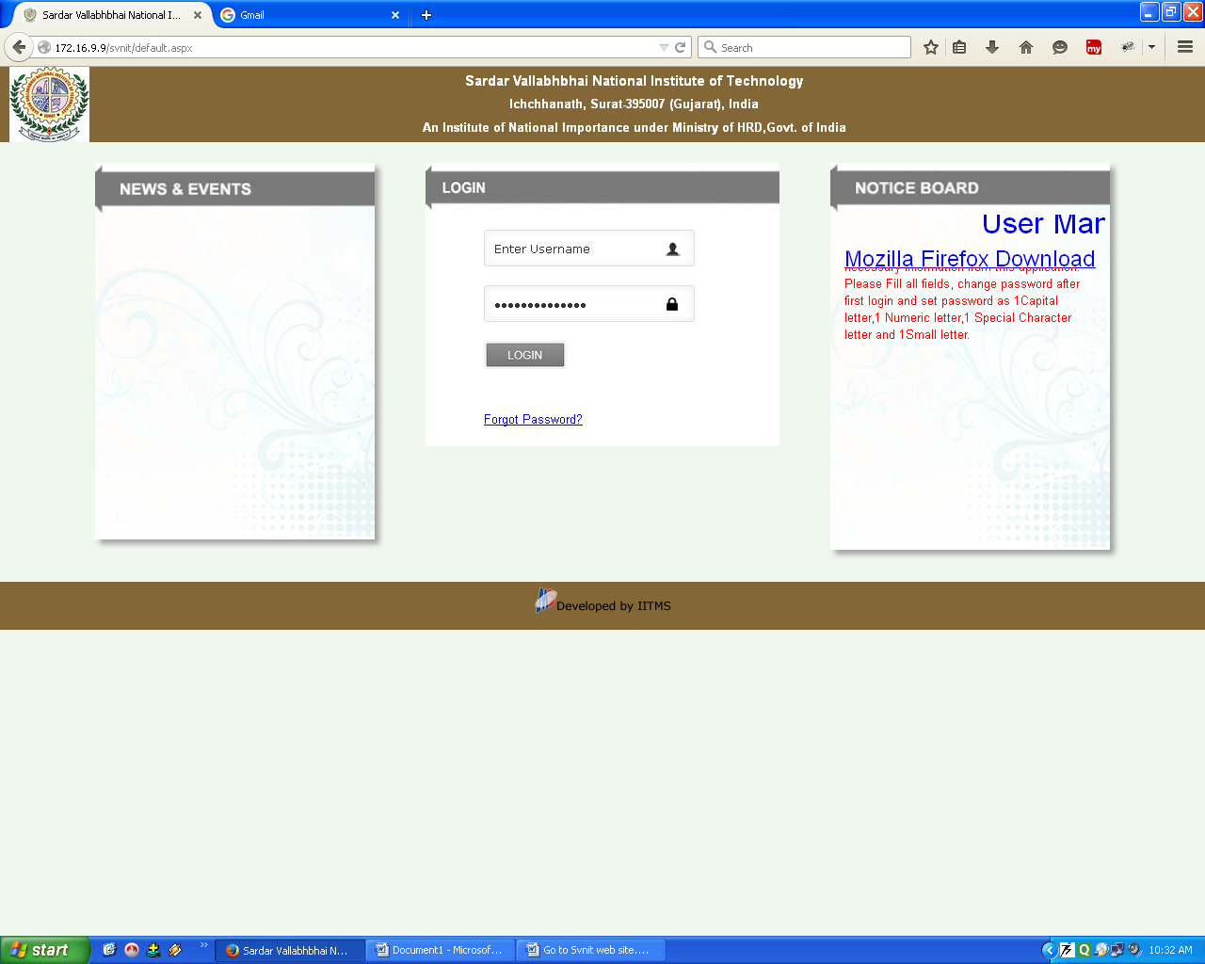

* Go to Academic menu 🡪 student section- Transaction 🡪 Course Teacher Allotment sub menu. Click on it.

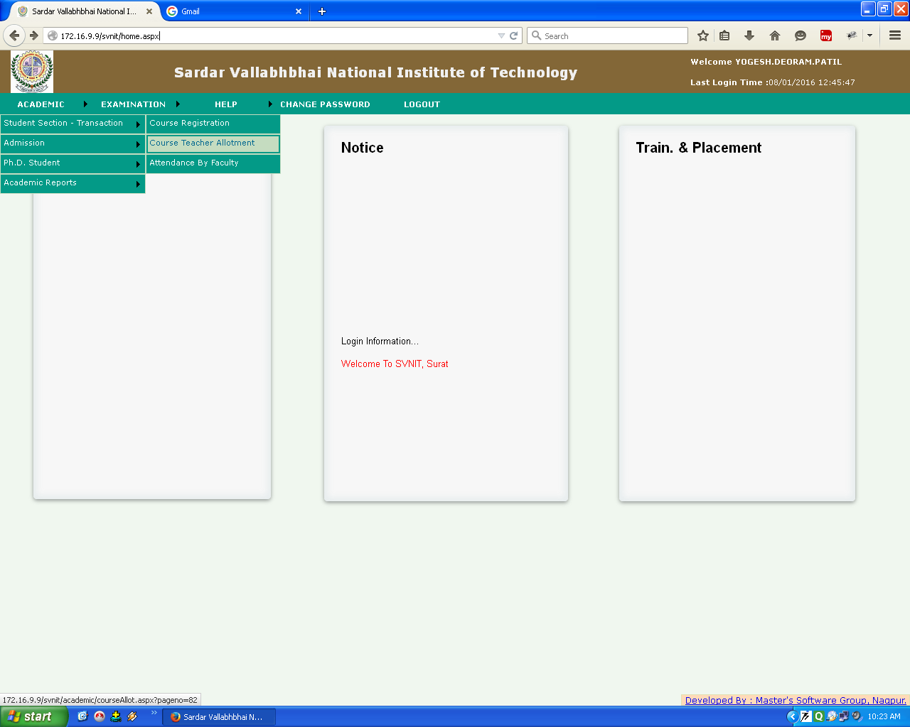

* Select Degree, Branch, Semester, section and course.
* Select Faculty name (Subject Co-coordinator) as per Division wise and click on Submit Button.

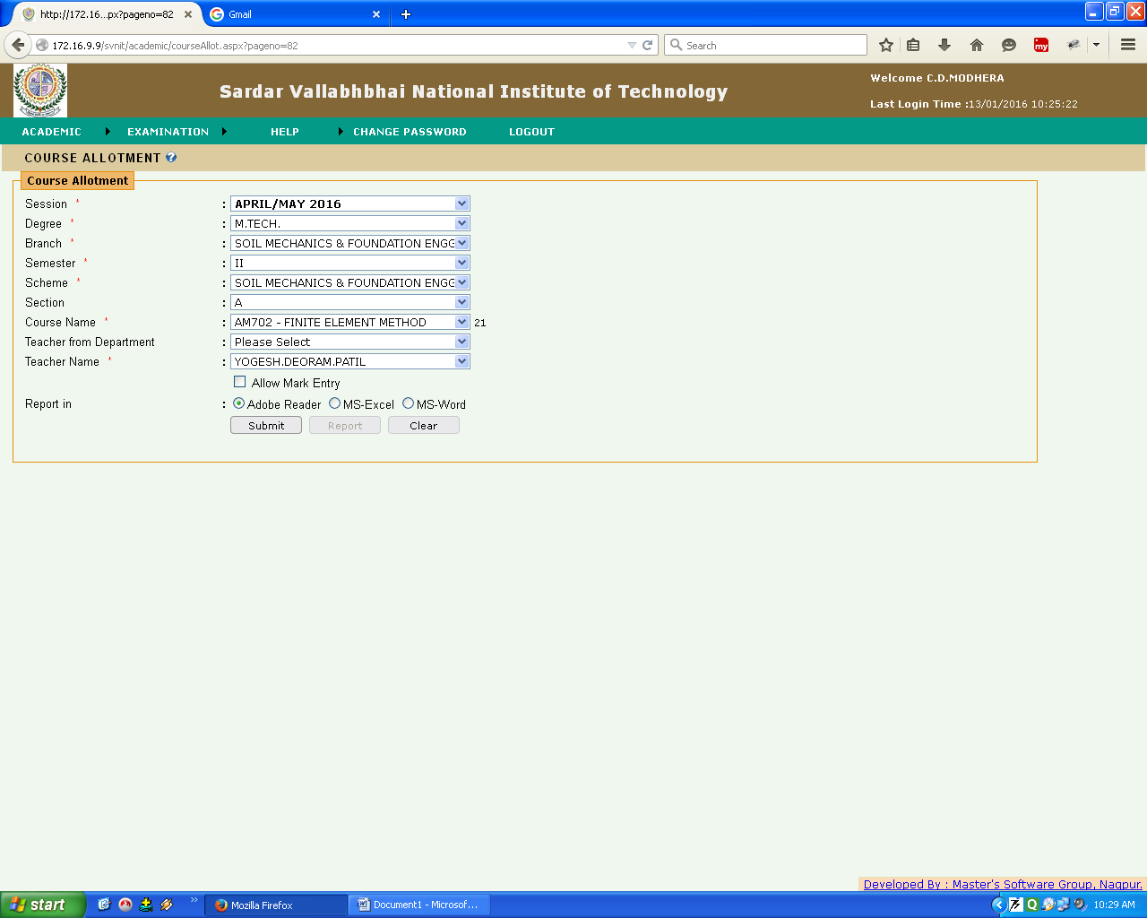

* And Only for Course Coordinator, does Check the Allow mark Entry option and click on submit button.

